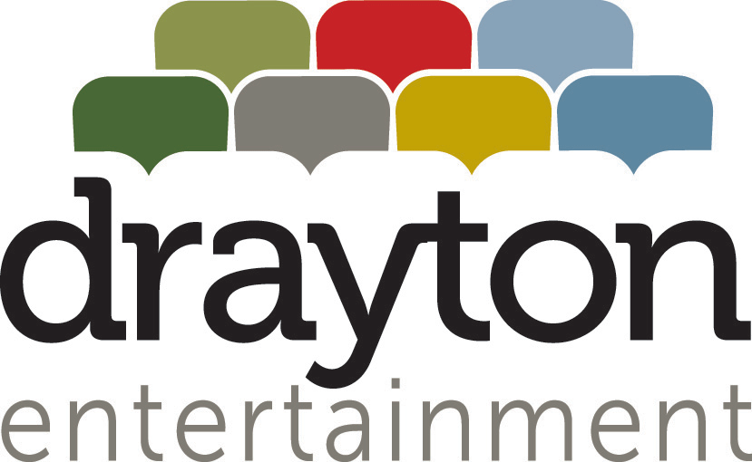

ORGANIZATION DESCRIPTION
Drayton Entertainment is a registered, not-for-profit charitable organization and one of Canada's most successful professional theatre companies. We present the finest in live theatre for all ages at seven unique venues across Ontario: the Drayton Festival Theatre in Drayton, Huron Country Playhouse (Mainstage and South Huron Stage) in Grand Bend, King's Wharf Theatre in Penetanguishene, St. Jacobs Country Playhouse and Hildebrand Schoolhouse Theatre in St. Jacobs, and the Hamilton Family Theatre Cambridge. We also operate a Youth Academy in Waterloo.

Drayton Entertainment is committed to inclusion and diversity in hiring, and encourages all qualified candidates to apply without regard to age, disability, ethno-cultural identity, sexual orientation, gender identity, or any other historically underrepresented and marginalized identities.

Drayton Entertainment is committed to providing all workers with a barrier free work environment free of discrimination and harassment. If reasonable accommodation is needed to participate in the employment selection process, please reach out directly to Natasha Hopf, Director of Human Resources, at natasha@draytonentertainment.com or 519-621-5511 ext.240 so that we may provide assistance.

BARTENDER (SEASONAL, FULL-TIME)

Reports to Facility Manager

Function A friendly and enthusiastic individual who enjoys interacting with the public effectively and efficiently, the Bartender is responsible for providing exceptional customer service while overseeing and maintaining the lobby area for all theatre theatre productions and events. This position completes all sales for bar, concessions, and merchandise in a fast-paced, exciting live theatre environment.

Duties and Responsibilities include but are not limited to:

- Provide superior customer service, including knowledge of a variety of products, theatre programming, directions, and other common customer inquiries.
- Process all bar sales using point-of-sale system, including troubleshooting.
- Comply with all liquor laws as they pertain to the facility, and adhere to all health and safety laws concerning the serving and handling of all products.
- Complete reporting and reconciliation procedures of all sales at end of shift, including bank deposits and balance after each shift.
- Maintain inventory, sales, and incoming product, including ordering as instructed.
- Provide service for a range of exciting events and festivities, including Opening Nights, receptions, private client events, fundraisers, and other special programs.

REQUIRED SKILLS & QUALIFICATIONS

- Enthusiasm for, and appreciation of, live theatre and the many people accessing the venue on a daily basis.
- Demonstrated maturity in working with the public, coupled with excellent customer service skills.
- Previous experience in bartending or customer service industry.
- Smart Serve Training & Certification is required; experience with point-of-sale systems is an asset; First Aid Training is an asset.
- Ability to perform physical task demands such as lifting, bending, and standing for extended periods of time.
- Flexibility in schedule, as the position runs in conjunction with theatre programming and involves daytime, evening, and weekend shifts.

TERM: Full-time & Seasonal.

This position is available at each of the following venues:
- Huron Country Playhouse, Grand Bend (Full-Time & Seasonal; May 29 to Aug 31)
- King’s Wharf Theatre, Penetanguishene (Full-Time & Seasonal; June 9 to Aug 31)

Due to the nature of the live theatre industry, daytime, evening and weekend work will be required.

HOW TO APPLY

For consideration, interested candidates should respond with Cover Letter & CV by March 15, 2025 to:

Ellen Berwick
Director of Audience Services
Email: ellenb@draytonentertainment.com

Please clearly indicate on your submission your preferred theatre location.

We thank all applicants for their interest; however only those selected for an interview will be contacted.

